Terraform modules
Even when you don't create a module intentionally, if you use Terraform, you are already writing a module – a so-called "root" module.
Any Terraform configuration file (.tf) in a directory, even just one, forms a module.
What does a module do?
A Terraform module allows you to create logical abstraction on the top of some resource set. In other words, a module allows you to group resources together and reuse this group later, possibly many times.
Let's assume we have a virtual server with some features hosted in the cloud. What set of resources might describe that server? For example:
the virtual machine itself, created from some image
an attached block device of a specified size for additional storage
a static public IP mapped to the server's virtual network interface
a set of firewall rules to be attached to the server
other things like another block device, additional network interface, and so on
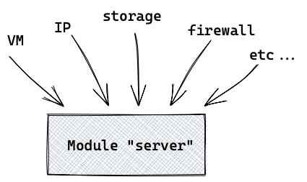
Now let's assume that you need to create this server with a set of resources many times. This is where modules are really helpful – you don't want to repeat the same configuration code over and over again, do you?
Here is an example that illustrates how our "server" module might be called.
"To call a module" means to use it in the configuration file.
Here we create 5 instances of the "server" using single set of configurations (in the module):
module "server" {

count = 5

source = "./module_server"
some_variable = some_value
}
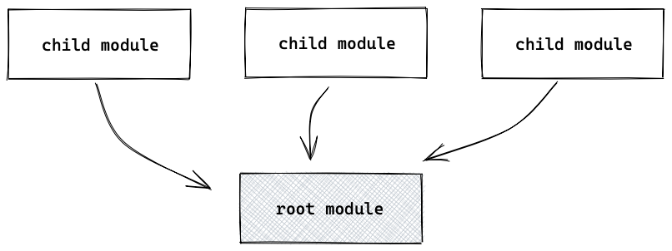

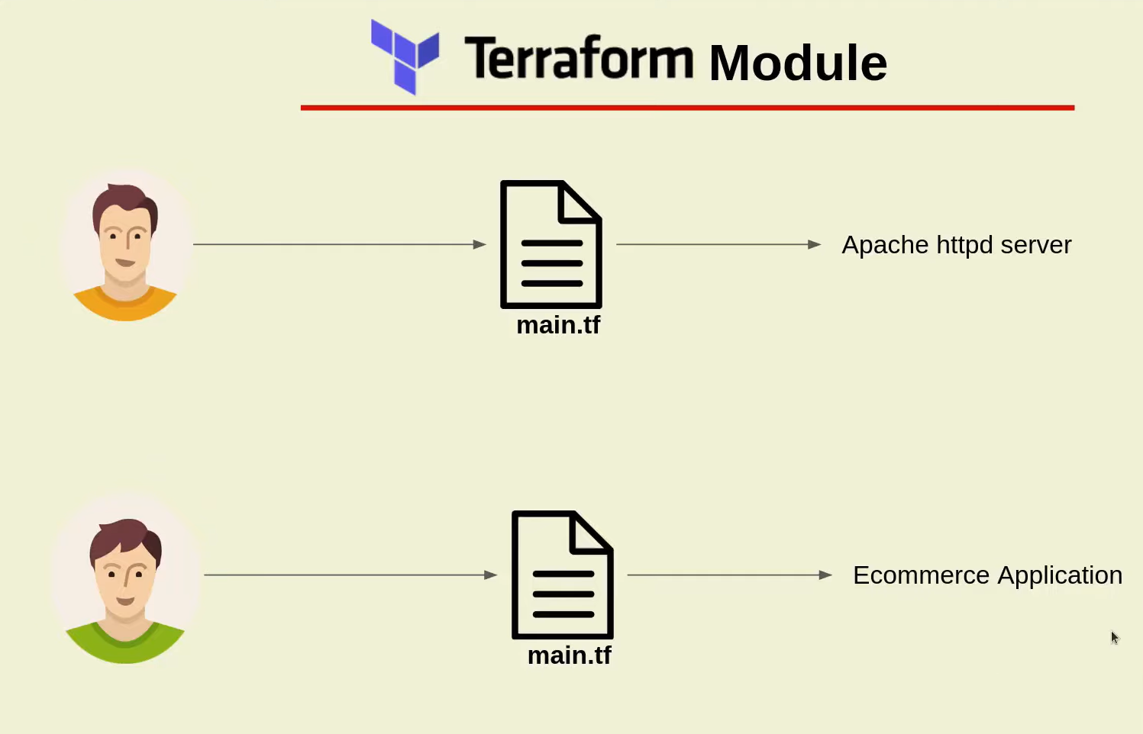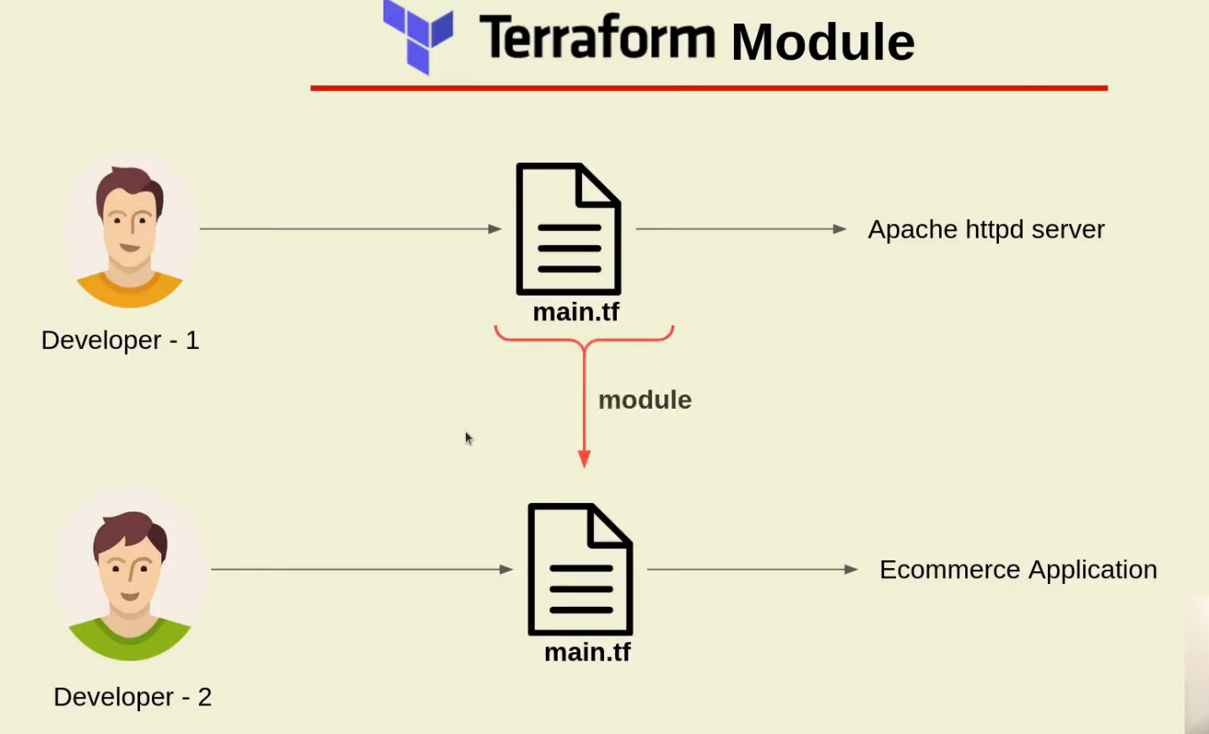
How Terraform modules works?
Terraform is an IaC(infrastructure as Code) framework for managing and provisioning the infrastructure but have you ever thought of creating only a single terraform configuration file for managing the complete cloud infrastructure.
Well, it sounds insane because if you only have a single file for managing the complete infrastructure then it will grow in complexity as well the line of configuration code will be manifold. That is why terraform introduced a concept of module which will help you to organize your terraform configuration so that you can re-use the configuration and keep your terraform code more clean and modular.
In this blog post, we will create two modules module-1 and module-2. Inside each module, we will install the apache httpd server and nginx server with each module is having its home page.
Steps for creating terraform modules along with best practices and benefits
Create your first module
Module structure
Calling the module
Module Inputs
Module Output
Module best practices
Benefits of Modules

1. Create your first module
To keep things simple we will be creating two modules named module-1, module-2.
Each module will have its own main.tf files.
Terraform modules with its own main.tf files
1.1Install apache httpd server and Nginx in module-1 and module-2
To keep things more regular we will install two apache httpd servers in each module.
Let us start with the module-1 -
1. Specify the terraform required version
terraform {
required_version = ">=0.12"
}

2. Create an ec2 aws_instance along with the user_data block in which we will be writing bash commands for installing the apache2 httpd server.
(Note - Here in this instance I have used the key_name aws_key. Follow this post on how to create aws keys for your ec2 instance )
resource "aws_instance" "ec2_example" {

ami = "ami-0767046d1677be5a0"
instance_type = "t3.micro"
key_name= "mr-cloud-book"
vpc_security_group_ids = [aws_security_group.main.id]
}

and here is the user_data block for installing the apach2 httpd server.
We will be using the same user_data block for installing the apache2 httpd server .
user_data = <<-EOF
#!/bin/bash
sudo su
yum update -y
yum install -y httpd
cd /var/www/html
wget https://github.com/azeezsalu/techmax/archive/refs/heads/main.zip
unzip main.zip
cp -r techmax-main/* /var/www/html/
rm -rf techmax-main main.zip
systemctl enable httpd
systemctl start httpd
EOF

Module – 2
user_data = <<-EOF #cd /etc/nginx #cat nginx.conf
#!/bin/sh
sudo yum install epel-release #cd /usr/share/nginx/html
sudo yum update
sudo amazon-linux-extras install nginx1 –y
sudo systemctl status nginx
sudo systemctl start nginx
EOF

3. Define the aws_security_group along with ingress rules for port 80 and 22.
We need to open the port 80 on the ec2 instance to access the apache httpd server home page and port 22 will need to ssh into the ec2 instance.
Here is the resource block -
resource "aws_security_group" "main" {
name = "EC2-webserver-SG-2"
description = "Webserver for EC2 Instances"

ingress {
from_port = 80
protocol = "TCP"
to_port = 80
cidr_blocks = ["0.0.0.0/0"]
}

ingress {
from_port = 22
protocol = "TCP"
to_port = 22
cidr_blocks = ["115.97.103.44/32"]
}

egress {
from_port = 0
protocol = "-1"
to_port = 0
cidr_blocks = ["0.0.0.0/0"]
}
}
BASH

4. Complete terraform script for module-1 and module -2
module-1
terraform {
required_version = ">=0.12"
}

resource "aws_instance" "ec2_example" {

ami = "ami-0767046d1677be5a0"
instance_type = "t3.micro"
key_name= "mr-cloud-book"
vpc_security_group_ids = [aws_security_group.main.id]

user_data = <<-EOF
#!/bin/bash
sudo su
yum update -y
yum install -y httpd
cd /var/www/html
wget https://github.com/azeezsalu/techmax/archive/refs/heads/main.zip
unzip main.zip
cp -r techmax-main/* /var/www/html/
rm -rf techmax-main main.zip
systemctl enable httpd
systemctl start httpd

EOF
}

resource "aws_security_group" "main" {
name = "EC2-webserver-SG-1"
description = "Webserver for EC2 Instances"

ingress {
from_port = 80
protocol = "TCP"
to_port = 80
cidr_blocks = ["0.0.0.0/0"]
}

ingress {
from_port = 22
protocol = "TCP"
to_port = 22
cidr_blocks = ["0.0.0.0/0"]
}

egress {
from_port = 0
protocol = "-1"
to_port = 0
cidr_blocks = ["0.0.0.0/0"]
}
}

module-2
terraform {
required_version = ">=0.12"
}

resource "aws_instance" "ec2_example" {

ami = "ami-0767046d1677be5a0"
instance_type = "t2.micro"
key_name= "aws_key"
vpc_security_group_ids = [aws_security_group.main.id]

user_data = <<-EOF
#!/bin/bash
sudo su
yum update -y
amazon-linux-extras install nginx1 -y
systemctl enable nginx
systemctl start nginx
systemctl status nginx
sudo echo <!DOCTYPE html> <html> <head> <meta name="viewport" content="width=device-width, initial-scale=1"> <title>youtube Allow Fullscreen</title> </head> <body> <!--Need Internet Connection--> <!--Fullscreen allow--> <iframe width="420" height="315" src="https://www.youtube.com/embed/OK7fy40Ai6A" allowfullscreen></iframe> </body> </html>" > /usr/share/nginx/html/index.html
systemctl restart nginx

}

resource "aws_security_group" "main" {
name = "EC2-webserver-SG-1"
description = "Webserver for EC2 Instances"

ingress {
from_port = 8080
protocol = "TCP"
to_port = 8080
cidr_blocks = ["0.0.0.0/0"]
}

ingress {
from_port = 22
protocol = "TCP"
to_port = 22
cidr_blocks = ["115.97.103.44/32"]
}

egress {
from_port = 0
protocol = "-1"
to_port = 0
cidr_blocks = ["0.0.0.0/0"]
}
}

...
BASH

2. Module structure
In the step 1 we have seen the main.tf terraform files of module-1 and module-2.
Now let's talk about the complete structure of your terraform project where you will have your parent main.tf file which will be calling the module-1 and module-2
terraform modules with parent module terraform file main.tf

3. Calling the module
Alright in the previous steps we have seen how our modules main.tf files along with the structure of the modules along with the parent main.tf files.
Once you define the modules the next important step would be to call the modules from the parent main.tf file and terraform makes it easy to call the modules based on the relative paths-
Here is my parent main.tf calling the module-1 and module-2
provider "aws" {
region = var.web_region
access_key = var.access_key
secret_key = var.secret_key
}

module "webserver-1" {
source = ".//module-1"
}

module "webserver-2" {
source = ".//module-2"
}
BASH

4. Module Inputs
Just like any other programming language terraform also supports re-usability with the help of terraform module. You might be familiar with the concept of functions in other programming languages. In general functions always have some input parameter which needs to passed during the function call, similarly terraform module can also accept input parameters.
Example -
Let's take the same example where we have defined the module-1 but instead of hard coding ec2 instance type let's create an input variable which can be passed later -
1. Create a input variable inside module
Here is code snippet of module-1 where I have replaced hardcoded instance type to a variable var.web_instance_type -
Path - terraform-modules/module-1/main.tf
resource "aws_instance" "ec2_module_1" {

ami = var.ami_id
instance_type = var.web_instance_type
key_name= "aws_key"
vpc_security_group_ids = [aws_security_group.main.id]

user_data = <<-EOF
#!/bin/sh
sudo apt-get update
sudo apt install -y apache2
sudo systemctl status apache2
sudo systemctl start apache2
sudo chown -R $USER:$USER /var/www/html
sudo echo "<html><body><h1>Hello this is module-1 at instance id `curl http://169.254.169.254/latest/meta-data/instance-id` </h1></body></html>" > /var/www/html/index.html
EOF
}
BASH

2. Pass the module input variable value while calling terraform module
In the following code snippet we are calling module-1 but also we are passing input variable .i.e. web_instance_type="t2.large", so based on your need and environment you can update instance type without changing the code your terraform module.
Path - terraform-modules/main.tf
provider "aws" {
region = var.web_region
access_key = var.access_key
secret_key = var.secret_key
}

module "webserver-1" {
source = ".//module-1"

web_instance_type = "t2.large"
}

module "webserver-2" {
source = ".//module-2"
}

BASH

5. Module Output
Terraform module also have the capability to produce the return output just like function which do return some value back after calling them.
Example -
1. Create an output variable public_ip_ec2
Let's again take the example of same terraform module-1, define an output block inside terraform module-1.
The following code snippet is for adding an output variable inside module-1 (Refer to GitHub for code repo)
Path - terraform-modules/module-1/main.tf
resource "aws_instance" "ec2_module_1" {

ami = var.ami_id
instance_type = var.web_instance_type
key_name= "aws_key"
vpc_security_group_ids = [aws_security_group.main.id]

user_data = <<-EOF
#!/bin/sh
sudo apt-get update
sudo apt install -y apache2
sudo systemctl status apache2
sudo systemctl start apache2
sudo chown -R $USER:$USER /var/www/html
sudo echo "<html><body><h1>Hello this is module-1 at instance id `curl http://169.254.169.254/latest/meta-data/instance-id` </h1></body></html>" > /var/www/html/index.html
EOF
}

output "public_ip_ec2" {
value = aws_instance.app_server.public_ip
description = "Public IP address of EC2 instance"
}
BASH

2. Use module output variable to show the output
After declaring module output variable inside terraform module we can refer to the output variable inside main. tf. But to access the output variable you need to use following syntax
module.<MODULE_NAME>.<OUTPUT_VARIABLE_NAME>
BASH
Here is the main.tf accessing the output variable public_ip_ec2
Path - terraform-modules/main.tf
provider "aws" {
region = var.web_region
access_key = var.access_key
secret_key = var.secret_key
}

module "webserver-1" {
source = ".//module-1"

web_instance_type = "t2.large"
}

output "public_ip_ec2" {
value = module.module-1.public_ip_ec2
description = "Public IP of EC2"
}

module "webserver-2" {
source = ".//module-2"
}

5. Module best practices
You must always write the provider name inside your terraform file. For example, if you are using the AWS then the following line should be added as provider -
provider "aws" {
}
For google you can write the provider in the following manner -
provider "google" {
}
While you are trying to write you're terraforming module always keep in mind that you have to go for simplicity and not to increase the complexity of your terraform project. Always keep the modules bare minimum if possible so that it will help other developers to understand and troubleshoot the issues if needed.
Terraform has a very good concept of local modules which you use to encapsulate your infrastructure logic. Use of modules is always recommended from the start of the project so that you have more control over the terraform code and it does not get spread sporadically.
Refer to the terraform public registry for finding more stable modules so that you do not have to re-invent the wheel.
Always keep and habit of publishing the modules so that it can be used by other teams members also

6. Benefits of Modules
Well, you will always get benefited from modules if you implement it properly. But here are certain advantages you will get with the terraform modules -
Organize configuration - With modules it is always easy to navigate and it helps any developer to understand the terraform project with ease. Certain with the module you can break down very complex infrastructure modules into very simplistic terraform modules.
Encapsulation - You can benefit from the encapsulation also and with terraform module you can hide the internal implementation of your infrastructure set up so that you can prevent unwanted changes happening to your modules by other developers.
Re-usability - If you have broken down your infrastructure into smaller and generic modules then it would help you to re-use the modules into another infrastructure setup.
Consistency - Following the best practices(encapsulation, organize, simple terraform module) will help you to achieve consistent behavior across all the different environments which will help you to reduce the debugging time and reduce the infrastructure maintenance cost.

